ARM vending machine terminal interface description
- Welcome to the main interface description
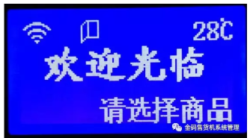
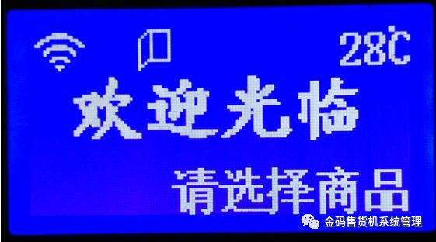
There will be basic information prompts on the welcome main interface:
1、
The appearance of this icon indicates that the vending machine has been connected to the platform server through the network, and the data communication with the platform server is normal, otherwise it means that there is no connection.
2、
The appearance of this icon indicates that the vending machine is currently in the open state, otherwise it is in the closed state.
3、
The area in the upper right corner of the main interface displays the current cabinet cooling temperature of the vending machine.
4、The bottom line of the main interface displays the current working status of the vending machine
(1) "Please select a product"
The vending machine is in normal sales.
(2) "Out of Service 1"
The vending machine cannot find a payment method or payment device that can be used. The reasons may be as follows:
1）In the case of only online payment, the vending machine loses connection with the platform server and 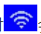will disappear at the same time.
2) In the case of online payment and card payment, the vending machine loses connection with the platform server, and at the same time it loses connection with the card reader.
3) In the case of payment only by swiping the card, the vending machine loses connection with the card reader.
(3) "out of service 2"
The vending machine cannot find the driver board, please check the connection of the driver board.
二、Vending machine detailed working status interface description
Press the "0" key in the main interface to enter the first screen of the detailed working status interface of the vending machine, as shown in the figure below:
First screen interface
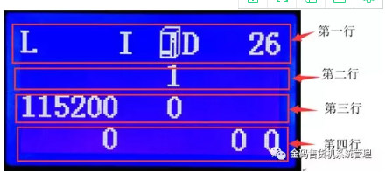
1 row
(1) "L"
The appearance of this letter indicates that the vending machine network module device is connected to mobile, telecommunications, China Unicom and other networks, but it does not mean that the data communication with the platform server is normal, otherwise it means that the mobile, telecommunications, China Unicom and other networks are not connected.
(2) "H"
The appearance of this letter indicates that the coin device currently connected to the vending machine is Hopper.
(3) "C"
The appearance of this letter indicates that the coin device currently connected to the vending machine is a coin device, and the coin device is connected normally, otherwise it is not recognized when the coin device is a coin device.
(4) "B"
The appearance of this letter indicates that the vending machine is connected to the banknote device normally, otherwise it is not recognized.
(5) "I"
The appearance of this letter indicates that the vending machine recognizes the card reader, otherwise it does not recognize it (please note: only vending machines that support card reader swipe payment, vending machines without card readers also do not display this letter).
(6) "U"
The appearance of this letter indicates that the vending machine is currently connected to the UnionPay QuickPass hardware device, and the device is connected normally, otherwise it will not be recognized when the UnionPay silly hardware device is connected.
（7）
Container icon. The appearance of this icon indicates that the vending machine recognizes the drive board, otherwise it does not recognize it.
（8）“D”
The appearance of this letter means that the vending machine recognizes the drop detection device, otherwise it does not recognize it.
（9）
Snowflake icon. The appearance of this icon indicates that the vending machine's refrigeration system is working normally and is being refrigerated, otherwise the refrigeration system is closed and not working.
（10）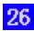
The number displayed in this area indicates the cooling temperature of the vending machine, which is consistent with the temperature display on the main interface.

2. The second line
(1) "S"
The appearance of this letter indicates that the scanning device currently connected to the vending machine is a bar code scanning device and is connected to the device normally, otherwise it will not be recognized when the scanning device is a bar code scanning device.
(2) "Q"
The appearance of this letter indicates that the scanning device currently connected to the vending machine is a Newland QR code scanning device, and the connection to the device is normal, otherwise it will not be recognized when the scanning device is a Newland QR code scanning device.
(3) "K"
The appearance of this letter indicates that the scanning device currently connected to the vending machine is a two-dimensional code scanning device, and the connection to the device is normal, otherwise it will not be recognized when the scanning device is a two-dimensional code scanning device.
(4) "X"
The appearance of this letter indicates that the storage space of the vending machine is full.
(5) "1"
The number displayed in this area indicates the current connection status of the network communication module, which is only displayed when the network communication module is a 3G or 4G module.
The connection status is detailed as follows:
1: Data communication is normal;
2: Shutdown state;
3: Set/query the baud rate of the network communication module;
4: Check whether the SIM card is inserted;
5: Registering for GSM;
6: Querying GPRS;
7: Establishing a TCP connection with the server;
8: Enter command mode from transparent transmission mode;
9: Restart the network communication module;
18: ICCID is being obtained;
19: Getting IMSI;
20: Getting IMEI.

- The third row
（1）
The number displayed in this area is the baud rate of the network communication module.
（2）
The number displayed in the red box is the number of restarts of the network communication module when the network is disconnected. After connecting to the network, it will be reset.
4、Fourth row
（1）
The number displayed in the red box is the quantity of the current vending machine to be sent.

Second screen interface
Press the "0" key to enter the next interface, as shown below:
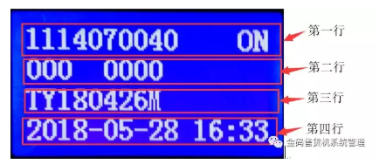
1. The first line
(1) "1114070040"
This area displays the factory number of the vending machine, which is different for each machine, which is equivalent to the machine's ID card.
(2) Networking function mark
"ON": indicates that the vending machine networking function is turned on, "OFF": indicates that the vending machine networking function is turned off.

- The second line
- （1）
The number displayed in the red box is the customer number.（2）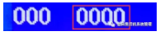
The number displayed in the area in the red box is the device number of the vending machine set by the operator.

3. The third row
(1) "TY180426M"
This area displays the program version number of the vending machine motherboard.

4. The fourth row
Display the current date and time of the vending machine.

The third screen interface
Press the "0" key to enter the next interface, which displays the cooling or heating settings, such as
下图：